LOCATION : NATIONWIDE
DATE : 06.01.2017
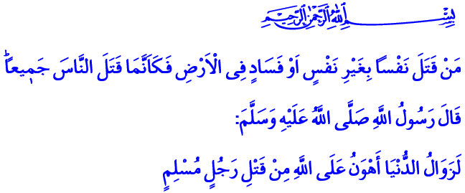
TODAY, WE UNITE AGAINST TERRORISM
A Blessed Friday to You, Brothers and Sisters!
We have been grieving in these days as a nation. Because we suffered disgustful terror attacks last week in Istanbul and yesterday in İzmir. The innocent lives we have lost once again tore our heart out. I wish Allah’s mercy to the ones we lost, a quick recovery to the wounded. I offer my condolences to their families. And condolences to our nation and the human family.
Honorable Brothers and Sisters!
As always expressed from this minbar, every human being is honorable in our faith. The right to life is sacred for everyone. Their life, property, dignity, and honor are untouchable. The Holy Quran says “Whoever kills a soul is as if he had slain the entire humankind.” The primary goal of our great religion Islam is to bring life to people. To make it better. To make it improve.
It should be known that all types of terrorism that target our existence have the same purpose even though their names, methods, mentality, and appearance are different. They hurt our unity, togetherness, and brotherhood. They destroy our culture of peaceful co-existence with our differences which offer richness. The purpose of terror is to make our hearts to be held hostage by the darkness of mischief and sedition, hatred and animosity, violence and hostility. Its aim is to drag us into a swirl of conflict and unrest. To weaken us. To kill our hopes for the future.
Brothers and Sisters!
In this difficult period we are going through, we desperately need the moral principles the Almighty taught us in the Surat al-Hujurat. Let us lend an ear to these vital principles in today’s khutbah.
The first principle is فَتَبَيَّنُٓوا which means “investigate.” Our Lord enjoins, “O you who have believed, if there comes to you an untrustworthy one with information, investigate.” Considering a piece of information true without investigating it and verifying its accuracy may lead us to wrong conclusions. It may cause undesired circumstances, sedition, and mischief. And as a result, we may regret what we have done.
Brothers and Sisters!
The second moral principle is to reconciliate as per the command فَاَصْلِحُوا. It is to resolve issues between people. It is to be constructive and corrective, not destructive and vindictive; to be unifying and inclusive, not divisive and disruptive. It is to join forces and make the power of love, fondness, and brotherhood prevail against the darkness of hostility, hatred, and violence. It is to band together and drain the swamp of division and conflict.
The third moral principle is to glorify justice by وَاَقْسِطُوا that is “acting justly.” It is to never let go of justice, loyalty, and righteousness under any circumstances.
Dear Brothers and Sisters!
The fourth moral principle taught to us by Surat al-Hujurat is which means لَا يَسْخَرْ “do not mock others.” It is to never scorn and despise anyone. It is to never forget that, as the children of Adam and Eve, we have been created from the same origin.
The fifth moral principle is to avoid defamation as per the command وَلَا تَلْمِزُٓوا اَنْفُسَكُمْ. It is to avoid offending a person even with a little gesture or implication. It is to keep away from any word or behavior that may hurt a person’s honor and dignity.
The sixth moral principle is, بِالْاَلْقَابِۜ وَلَا تَنَابَزُوا which means “Do not call each other by offensive nicknames.” Because a person’s name, honor, and reputation are esteemed and worthy of respect like the person himself.
Honorable Brothers and Sisters!
The seventh moral principle that the Surat al-Hujurat taught us is اجْتَنِبُوا كَث۪يرًا مِنَ الظَّنِّۚ that is to avoid making wrong assumptions about one another Because assumption about others often misleads and causes one to sin. It leads to misunderstandings and disturbances.
The eighth moral principle is the command وَلَا تَجَسَّسُوا. That is, do not spy and pry into the flaws and imperfections of others. It is to avoid attempting to expose others’ privacy. It is to remember that our real duty is to correct our own mistakes and flaws.
The ninth moral principle is بَعْضًاۜ وَلَا يَغْتَبْ that is “Do not backbite each other. Do not talk behind one another’s back.” Because our duty is to protect the rights of our brothers and sisters even when they are not present. It is to consider their existence as ours. To consider their honor as ours.
Brothers and Sisters!
May the Almighty Lord grant us to be among those who abide by these principles. May He grant us to be among those who get their morals from the morals of the Quran and of the Prophet. May the Lord never allow those who target our nation’s unity and togetherness. May He never allow harm upon our country and nation, the hope of the downtrodden.

Bukhari, İlim, 9.
Al-Ma’idah, 5/32.
Al-Hujurat, 49/1-18. Written by: General Directorate of Religious Services

